Extracurricular Activities
Protocol and Business Process Guidelines

Revision Date: 06/19/2012
P:\SA\Functional\Campus Community\Extracurricular Activities Policy Document.doc
Introduction

This document provides users of PeopleSoft Student Administration (SA) Extracurricular Activities functionality guidelines for maintaining the students within these Extracurricular Activities including responsibilities/expectations and commonly asked questions.

Prerequisites/Assumptions

Before you can use the PeopleSoft Student Administration system to maintain students within an Extracurricular Activity, it is assumed that each of the following conditions has been met:

- You have the necessary User ID and security access to the Student Administration system.
- Your request for the creation of an Extracurricular Activity has been reviewed and approved.
- Your Extracurricular Activity has been created in the student system.
- You have a general working knowledge of PeopleSoft navigation and terminology associated with Extracurricular Activities.

If You Need Further Assistance

When you apply the information found in this document, you may have further questions. Please visit http:/www.umbc.edu/sa for the latest information regarding end-user support.

Responsibilities/Expectations

A well-maintained Extracurricular Activity presents numerous opportunities to use the Extracurricular Activity for reporting and data analysis purposes. As such, it is imperative that Extracurricular Activities be kept up to date and accurate. Once you have had an Extracurricular Activity approved and created, there are several guidelines that should be followed:

- Students within an Extracurricular Activities should be maintained. For Extracurricular Activities that are cohort based, it is expected that updates for a semester will be completed by the 10th day of each semester. Non-cohort based Extracurricular Activities should be updated as soon as feasible once a student’s membership status for inclusion within an Extracurricular Activity has changed.
- At least one staff member will be designated as the Extracurricular Activity manager. This staff person will ultimately be responsible for Extracurricular Activity maintenance and integrity.
- Report Exchange (REX) reports should not be used for official UMBC reporting.
- Rex data should not be shared with other offices or external constituents without consulting with the respective Extracurricular Activity manager.

Common Questions

- What are Extracurricular Activities?
Extracurricular Activities enable tracking of students involved in extra- and co-curricular activities such as student clubs and organizations for data analysis purposes, reporting or communication facilitation.

- How do I request an Extracurricular Activity?

You can request an Extracurricular Activity through the RT Help link via myUMBC. After receiving your request, a meeting will be scheduled with you to discuss your needs. This is done to assure that an Extracurricular Activity is the appropriate tool to accomplish your goals.

- Who should go in the Extracurricular Activity?

Who goes into your Extracurricular Activity depends on the population you are attempting to track. In some cases, Extracurricular Activities may be related to a specific term, so new additions and inactivations are made each semester or academic year.

If the Extracurricular Activity is non-term based, students within these Extracurricular Activities are usually more fluid and are updated on an ad-hoc basis.

- Should Extracurricular Activity members be inactivated or deleted?

In general, Extracurricular Activity members should be inactivated using the End Date field. Examples of students who should be inactivated via an End Date are:
  - Students assigned to an Extracurricular Activity and then subsequently are no longer a member of the Extracurricular Activity
  - Students no longer eligible or participating in the Extracurricular Activity
  - Students who discontinue their enrollment or graduate
When inactivating a student from an Extracurricular Activity, users may opt to use the comment field to detail the reason(s) the student has been inactivated.

The End date is important. Report Exchange looks at the End date to determine whether a student is listed in Extracurricular Activity related reports for a particular semester. For example, a student whose End Date is after the start of the Fall semester will be counted in the Fall semester statistics for reporting purposes.

As an Extracurricular Activity manager, you have the ability to either back date or future date the End Dates, this functionality can be used to help manage whether and in what semesters a student will appear in your Extracurricular Activity reporting.

In cases where a student has been added to an Extracurricular Activity in error, they should be deleted from the Extracurricular Activity.

- What are the options regarding reporting?

REX (Reporting Exchange) is the tool of choice for report generation at UMBC. REX will allow for reporting on a broad range of admissions, enrollment, retention and graduation indicators by Extracurricular Activity. To request REX access and training submit a RT ticket via myUMBC.

- How do I access my Extracurricular Activity?

To maintain your Extracurricular Activity, you access your Extracurricular Activity via screens available in our student information system (PeopleSoft). You will be provided specific navigation and screen content training once your group has been created. You will also be able to access Extracurricular Activity related reporting in REX.

- How do I request access for additional staff members?

The most effective way is to complete a Campus Community access request form, which is available at https://wiki.umbc.edu/display/sa/SA+Home+Page .

- Can students be mass assigned into my Extracurricular Activity?

There is currently no automated way to mass assign students to an Extracurricular Activity.

1.0 Extracurricular Activity Maintenance

Each PeopleSoft user who has access to maintain their Extracurricular Activity will have the ability to add, delete, modify or review Extracurricular Activities for individual students.

The following tasks are associated with maintaining students within an Extracurricular Activity

1.1 Searching for a Student
1.2 Add a new Extracurricular Activity to a student’s record
1.3 Inactivate a student from a Extracurricular Activity

  - Searching for a Student
Navigation: Campus Community>Personal Information>Participation Data>Extracurricular Activities

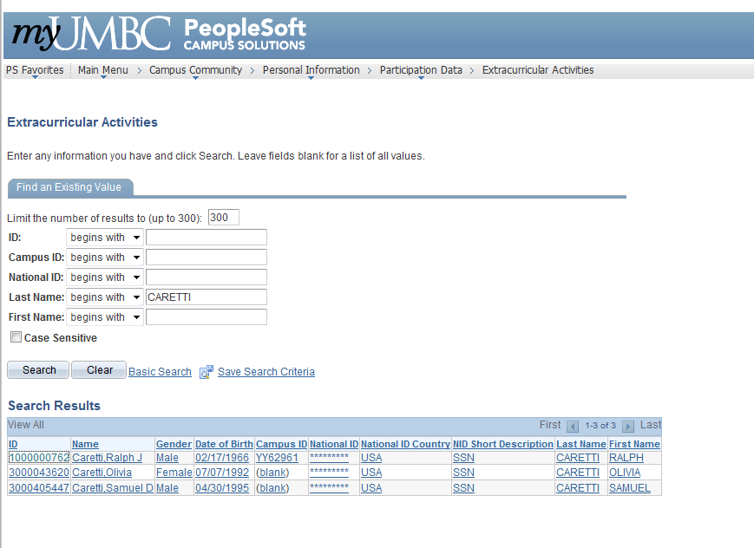

Step 1
Enter the Student ID or Campus ID.
If unknown;
Enter the Last Name – if the last name is extremely long, you may type a partial last name.
Enter the First Name

Step 2
Click the button.

Step 3
Select the student for which you wish to add an Extracurricular Activity.

  - Add a new Extracurricular activity to a student’s record
Navigation: Campus Community>Personal Information>Participation Data>Extracurricular Activities

As in section 1.1 above, you can search for a student via emplid, name, campus ID, or national id (ssn). If you enter a criteria that is specific to only one student (i.e. campus ID), that student’s information is displayed on the “Extracurricular Activity” screen as below. Enter identifying information and click the button.

If there are multiple students for the criteria entered, you will see a list (as below).

If you click on emplid 3000043620, the screen below will be displayed:

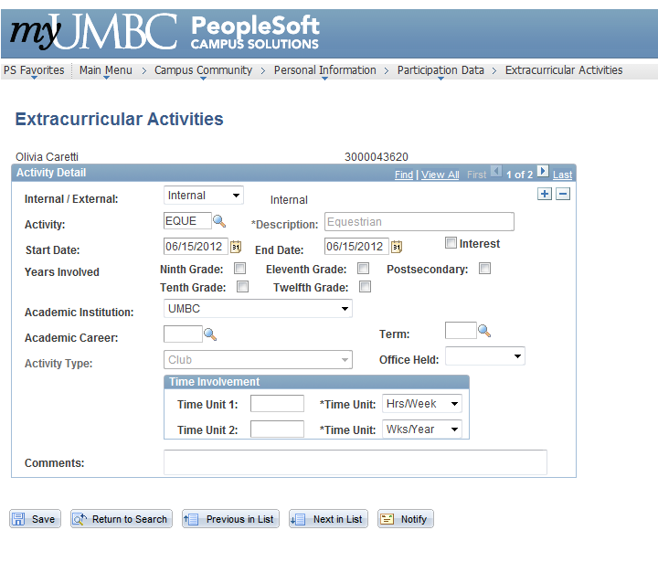

Note: In the case above, this person already has two Extracurricular Activities on their record. Notice the “1 of 2” on the upper right of the page. If a student has no Extracurricular Activities on their record, a blank page will be shown.

To add an Extracurricular Activity to the student selected, first determine if the student already has existing Extracurricular Activities. If the student does not have any current Extracurricular Activities, begin at Step 1 below. If a student has existing Extracurricular Activities, you must first click the 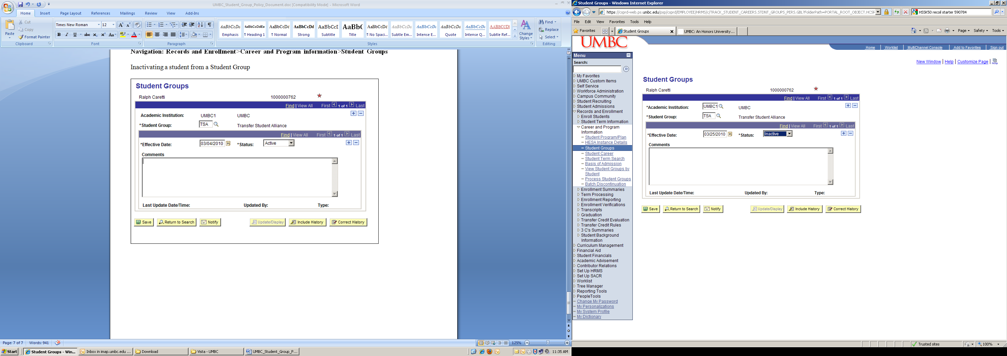 icon on the upper right of the page, then begin at Step 1 below.

Step 1 - Select whether the Extracurricular Activity is Internal or External

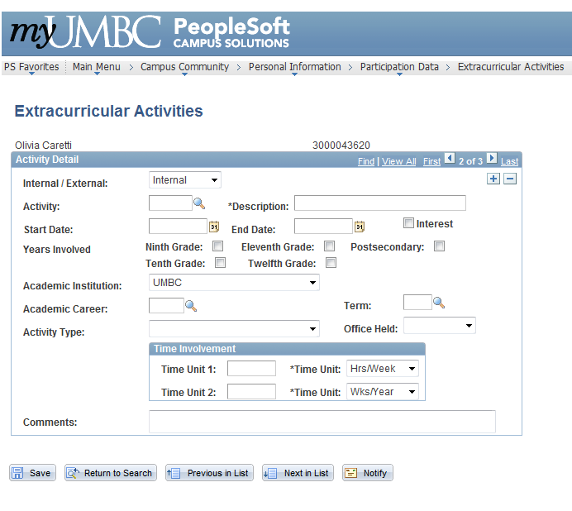

Step 2 - Select an Extracurricular Activity to add via the icon.

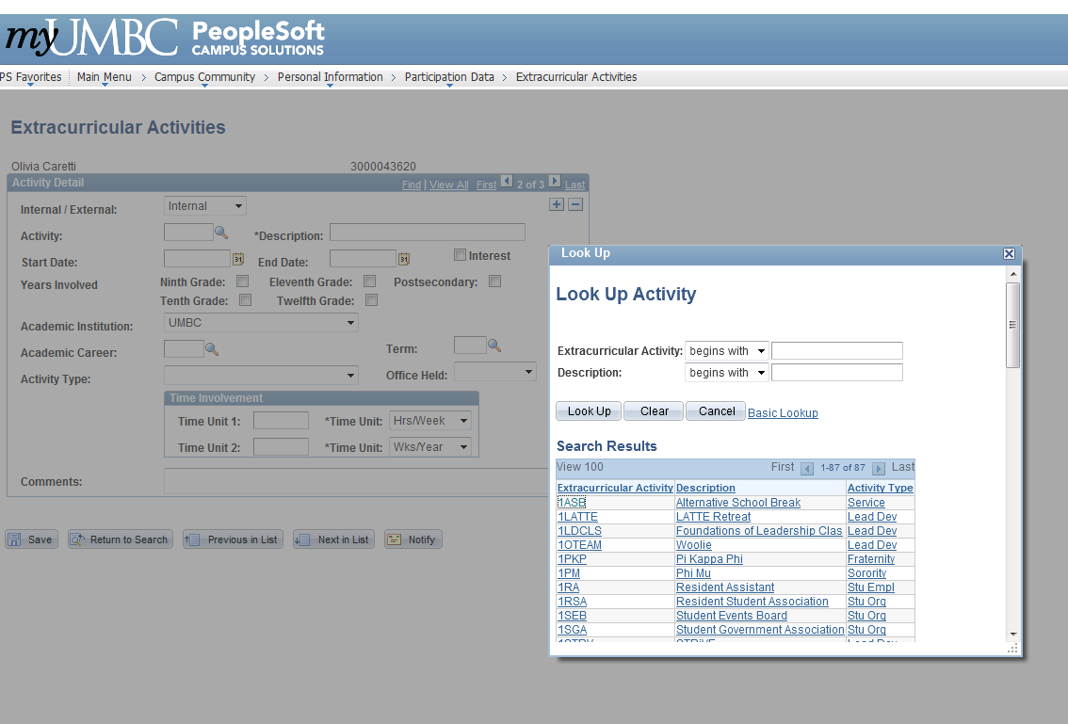

Step 3 - Enter the appropriate Start and End Date

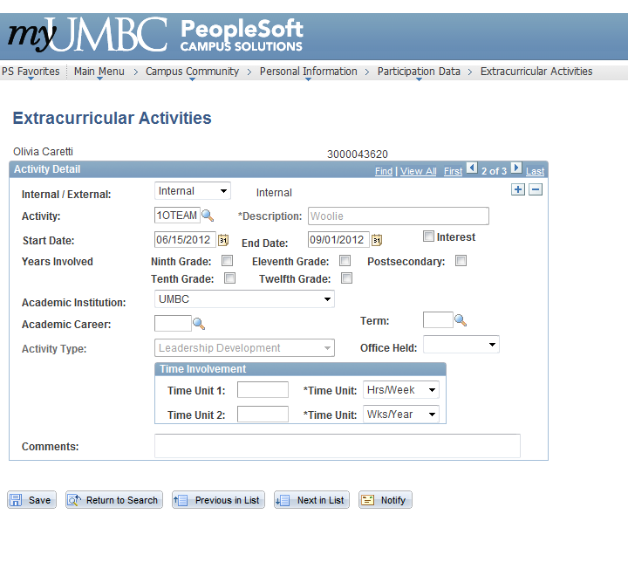

Step 4 - Enter any other information desired for the student.

This information may include Academic Career, term, time involvement, and comments.

Step 5 - Click

1.3 Inactivate a Student in a Student Group
Navigation: Campus Community>Personal Information>Participation Data>Extracurricular Activities

Step 1 - To inactivate a student from an Extracurricular Activity, first look up the student in the Extracurricular Activities Page as listed in 1.1 above.

Step 2 - Change the End Date to the last day the student was a member in the Extracurricular Activity.

Step 3 - Click

